Lab 3; Verification of the Maximum Power Transfer Theorem in an AC Circuit

Jake D. Karas

U0000008780

EEL3112C: Circuits 2

07/12/2022

**Objectives:**

The goal of this experiment was to determine the maximum power transfer in an AC circuit and find the load capable of providing it. This was accomplished utilizing the Maximum Power Transfer Theorem, which provides formulae for obtaining the load and power at this critical circuit parameter. The ideal load is the complex conjugate of the Thevenin equivalent impedance of the circuit, meaning that if there’s an inductor in the equivalent, there will be a capacitor in the load, and vice versa.

**Equipment:**

* Resistor x2
$120 Ω$

$200 Ω$

* Variable Resistor
* Inductor
$0.970 mH$

* Capacitor
$26 μF$

* AC Voltage Source (Function Generator)
* Multimeter (Oscilloscope)

**Theory Development:**

When a circuit is converted to a Thevenin equivalent circuit, it is in an opportune state to determine the maximum power transfer to the load between the terminals as well as the impedance of this load. By finding the partial derivatives of power with respect to the load resistance and the load reactance and then setting them to zero, it is found that the maximum power transfer occurs when $X_{L}= -X_{Th}$ and $R_{L}=\sqrt{R_{Th}^{2}+({X_{Th}+X_{L})}^{2}}$, and by combining these conditions, $R_{L}=R_{Th}$. Therefore, the ideal load impedance for maximum power transfer is the complex conjugate of the Thevenin equivalent impedance. In other words, $Z_{L}=R_{Th}-X_{Th}j=Z_{Th}^{*}$. From this, the maximum average power can be found to be $P_{max}=\frac{|V_{Th}|^{2}}{8R_{Th}}$, which is the quotient between the square of the Thevenin voltage’s magnitude and 8 times the Thevenin resistor’s value.

**Methods/Procedures:**

After obtaining the Thevenin equivalent impedance and source voltage via Hyperphysics, the values of the individual components were calculated backwards from the real and imaginary components of the impedance, with the closest available components being used to construct the physical circuit. The complex conjugate of the impedance was then taken as the ideal load impedance, however, a variable resistor was selected for the real component of the load impedance. This is because lastly, the real component of the load impedance would start from zero and be incremented by $7.5 Ω$ when measuring the peak voltage over the load with the oscilloscope until the variable resistor reached $150 Ω$, twice the ideal load resistance.

**Circuit Diagrams:**

Original Circuit:

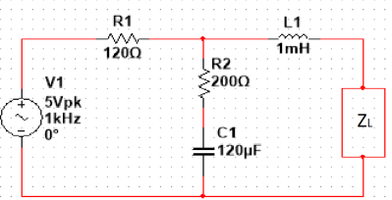

Final Circuit:

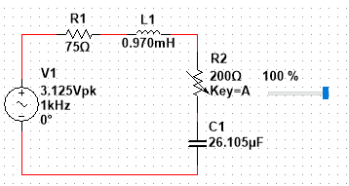

**Results (Theoretical and Experimental):**

Values Used:

$f=1 kHz$

$ω=2πf=2000π rad/s$

$V_{Th}=3.125∠-0.{14}^{o} V ppk=1.5625∠-0.14^{o} V$

$Z_{Th}=75.248∠4.6^{o} Ω$

$R_{Th}=75.0008 Ω (Closest: 75.820 Ω)$

$X_{Th}=6.09667881j Ω$

$L_{Th}=9.577 mH (Closest: 10.299 mH)$

* $Z_{L}=75.248∠-4.6^{o} Ω$ (Target Impedance)

$R_{L}=75.0008 Ω (Potentiometer)$

$X_{L}= -6.09667881j Ω$

$C_{L}=26.105 μF (Closest: 22.13 μF)$

| Theoretical | | | | |
| --- | --- | --- | --- | --- |
| $R_{L} (Ω)$ | $Z_{Total} (Ω)$ | $V_{L} (V pk)$ | $I_{L} (mA pk)$ | $P_{L} (mW pk)$ |
| $0$ | $75.001∠0^{o}$ | $0.127$ | $41.667$ | $2.646$ |
| $7.5$ | $82.501∠0^{o}$ | $0.284$ | $37.878$ | $5.381$ |
| $15$ | $90.001∠0^{o}$ | $0.521$ | $34.722$ | $9.042$ |
| $22.5$ | $97.501∠0^{o}$ | $0.721$ | $32.051$ | $11.557$ |
| $30$ | $105.001∠0^{o}$ | $0.893$ | $29.761$ | $13.287$ |
| $37.5$ | $112.501∠0^{o}$ | $1.042$ | $27.778$ | $14.468$ |
| $45$ | $120.001∠0^{o}$ | $1.172$ | $26.041$ | $15.259$ |
| $52.5$ | $127.501∠0^{o}$ | $1.287$ | $24.510$ | $15.769$ |
| $60$ | $135.001∠0^{o}$ | $1.389$ | $23.148$ | $16.075$ |
| $67.5$ | $142.501∠0^{o}$ | $1.480$ | $21.930$ | $16.231$ |
| $75$ | $150.001∠0^{o}$ | $1.562$ | $20.833$ | $16.276$ |
| $82.5$ | $157.501∠0^{o}$ | $1.637$ | $19.841$ | $16.239$ |
| $90$ | $165.001∠0^{o}$ | $1.705$ | $18.939$ | $16.141$ |
| $97.5$ | $173.501∠0^{o}$ | $1.756$ | $18.011$ | $15.815$ |
| $105$ | $180.001∠0^{o}$ | $1.823$ | $17.361$ | $15.824$ |
| $112.5$ | $188.501∠0^{o}$ | $1.865$ | $16.578$ | $15.459$ |
| $120$ | $195.001∠0^{o}$ | $1.923$ | $16.026$ | $15.049$ |
| $127.5$ | $203.501∠0^{o}$ | $1.958$ | $15.356$ | $15.033$ |
| $135$ | $210.001∠0^{o}$ | $2.009$ | $14.881$ | $14.947$ |
| $142.5$ | $217.501∠0^{o}$ | $2.047$ | $14.368$ | $14.708$ |
| $150$ | $225.001∠0^{o}$ | $2.083$ | $13.889$ | $14.467$ |

$P_{max}=16.276 mW$ at $R_{L}=75 Ω$

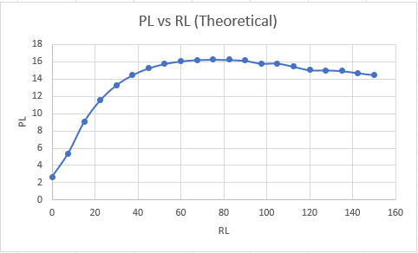

| Experimental (Multisim) | | | | |
| --- | --- | --- | --- | --- |
| $R_{L} (Ω)$ | $Z_{Total} (Ω)$ | $V_{L} (V pk)$ | $I_{L} (mA pk)$ | $P_{L} (mW pk)$ |
| $0$ | $75.001∠0^{o}$ | $0.253$ | $41.55$ | $5.246$ |
| $7.5$ | $82.501∠0^{o}$ | $0.365$ | $37.80$ | $6.899$ |
| $15$ | $90.001∠0^{o}$ | $0.560$ | $34.65$ | $9.702$ |
| $22.5$ | $97.501∠0^{o}$ | $0.745$ | $32.00$ | $11.920$ |
| $30$ | $105.001∠0^{o}$ | $0.910$ | $29.70$ | $13.513$ |
| $37.5$ | $112.501∠0^{o}$ | $1.055$ | $27.75$ | $14.638$ |
| $45$ | $120.001∠0^{o}$ | $1.180$ | $26.00$ | $15.340$ |
| $52.5$ | $127.501∠0^{o}$ | $1.295$ | $24.45$ | $15.831$ |
| $60$ | $135.001∠0^{o}$ | $1.395$ | $23.10$ | $16.112$ |
| $67.5$ | $142.501∠0^{o}$ | $1.485$ | $21.90$ | $16.261$ |
| $75$ | $150.001∠0^{o}$ | $1.565$ | $20.80$ | $16.276$ |
| $82.5$ | $157.501∠0^{o}$ | $1.640$ | $19.80$ | $16.236$ |
| $90$ | $165.001∠0^{o}$ | $1.705$ | $18.90$ | $16.112$ |
| $97.5$ | $173.501∠0^{o}$ | $1.765$ | $18.10$ | $15.973$ |
| $105$ | $180.001∠0^{o}$ | $1.825$ | $17.35$ | $15.831$ |
| $112.5$ | $188.501∠0^{o}$ | $1.875$ | $16.65$ | $15.609$ |
| $120$ | $195.001∠0^{o}$ | $1.925$ | $16.00$ | $15.400$ |
| $127.5$ | $203.501∠0^{o}$ | $1.970$ | $15.4$ | $15.169$ |
| $135$ | $210.001∠0^{o}$ | $2.010$ | $14.85$ | $14.924$ |
| $142.5$ | $217.501∠0^{o}$ | $2.045$ | $14.35$ | $14.673$ |
| $150$ | $225.001∠0^{o}$ | $2.080$ | $13.90$ | $14.456$ |

$P_{max}=16.276 mW$ at $R_{L}=75 Ω$

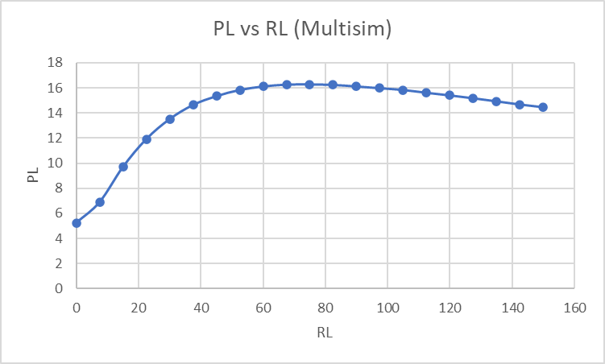

| Experimental (Hardware) | | | | |
| --- | --- | --- | --- | --- |
| $R_{L} (Ω)$ | $Z_{Total} (Ω)$ | $V_{L} (V pk)$ | $I_{L} (mA pk)$ | $P_{L} (mW pk)$ |
| $0$ | $75.820∠0^{o}$ | $0.56$ | $7.386$ | $4.136$ |
| $7.5$ | $82.320∠0^{o}$ | $0.68$ | $8.260$ | $5.617$ |
| $15$ | $90.820∠0^{o}$ | $0.92$ | $10.130$ | $9.320$ |
| $22.5$ | $97.320∠0^{o}$ | $1.12$ | $11.508$ | $12.889$ |
| $30$ | $105.820∠0^{o}$ | $1.32$ | $12.474$ | $16.466$ |
| $37.5$ | $112.320∠0^{o}$ | $1.52$ | $13.533$ | $20.570$ |
| $45$ | $120.820∠0^{o}$ | $1.76$ | $14.567$ | $25.638$ |
| $52.5$ | $127.320∠0^{o}$ | $1.96$ | $15.394$ | $30.173$ |
| $60$ | $135.820∠0^{o}$ | $2.12$ | $15.609$ | $33.091$ |
| $67.5$ | $142.320∠0^{o}$ | $2.28$ | $16.020$ | $36.526$ |
| $75$ | $150.820∠0^{o}$ | $2.44$ | $16.178$ | $39.475$ |
| $82.5$ | $157.320∠0^{o}$ | $2.60$ | $16.526$ | $42.970$ |
| $90$ | $165.820∠0^{o}$ | $2.76$ | $16.645$ | $45.939$ |
| $97.5$ | $173.320∠0^{o}$ | $2.88$ | $16.617$ | $47.856$ |
| $105$ | $180.820∠0^{o}$ | $3.00$ | $16.591$ | $49.773$ |
| $112.5$ | $188.320∠0^{o}$ | $3.08$ | $16.355$ | $50.374$ |
| $120$ | $195.820∠0^{o}$ | $3.20$ | $16.342$ | $52.292$ |
| $127.5$ | $203.320∠0^{o}$ | $3.24$ | $15.935$ | $51.631$ |
| $135$ | $210.820∠0^{o}$ | $3.32$ | $15.748$ | $52.283$ |
| $142.5$ | $217.320∠0^{o}$ | $3.40$ | $15.645$ | $53.193$ |
| $150$ | $225.820∠0^{o}$ | $3.52$ | $15.588$ | $54.868$ |

$P_{max}=54.868 W$ at $R_{L}=150 Ω$

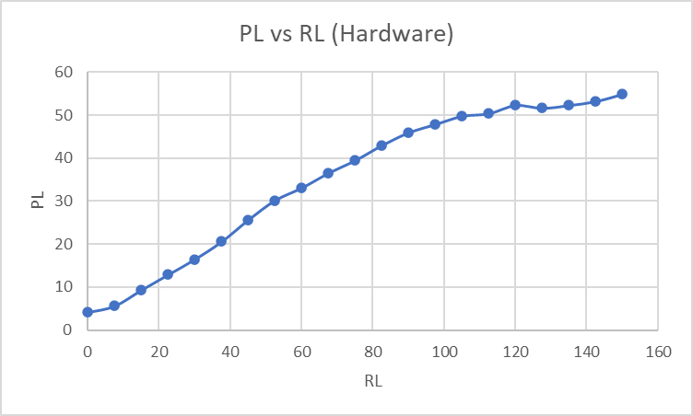

**Results Analysis and Discussion:**

While there were only marginal differences between the voltage, current, and power values between the theoretical and simulated circuits, a simple mistake when constructing the physical circuit led to the actual values varing greatly and creating a different graphical curve compared to the prior circuits. This was accidentally using a 10 mH inductor for the Thevenin equivalent impedance cluster rather than the ideal 1 mH inductor. It caused the curve to increment much longer than it did in the other 2 circuit variants, which peaked at $75 Ω$ before decrementing less quickly than they incremented. Next time, better care should be taken when selecting components for the hardware circuit of the experiment to avoid having avoidable error.

**Conclusion:**

Obtaining the maximum power transfer between the terminals of an AC circuit is one of the most important applications of Thevenin equivalent circuits. As demonstrated by this experiment, maximum power transfer occurs when the load impedance is set to the complex conjugate of the Thevenin equivalent impedance. Care must be taken when choosing the components to construct such circuit physically, as otherwise, the results may not be as expected.

Reference:

<http://hyperphysics.phy-astr.gsu.edu/hbase/electric/acthev.html#:~:text=AC%20Thevenin%20Example,therefore%20a%20a%20series%2Dparallel%20combination>